Had to delete the first try:
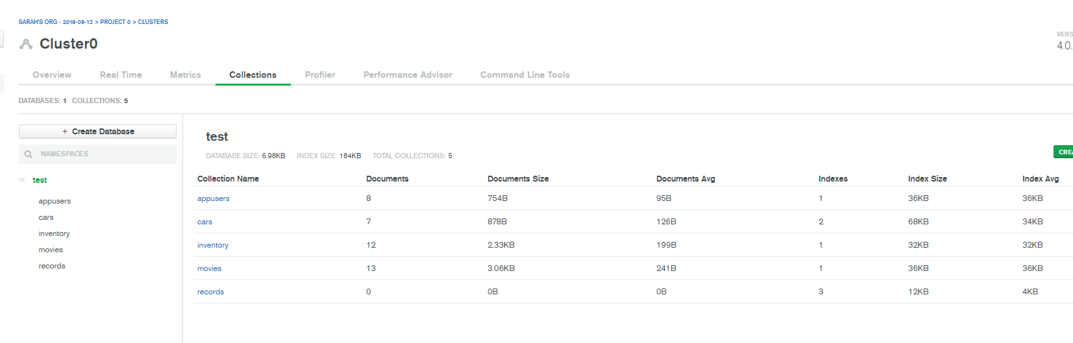

Okay on doing the things!!
db.employees.insertMany({{Name: 'Alison Davidson', Birthday: new Date('1975-04-05'), Address: '874 W. Oak Place', City: 'Gary', State: 'Indiana', Position: { {pName: 'Customer Support', Remote: 'True', fullTime : 'True'}}, {Name: 'Henry Chapelton', Birthday: new Date('1980-09-29'), Address: '9324 E. Vista Way', City: 'Tempe', State: 'Arizona', Position: { {pName: 'Customer Support', Remote: 'Fales', fullTime: 'True'}}, {Name: 'Alex Miller', Birthday: new Date('1983-11-22'), Address: '244 Price Road', City: 'Mesa', State: 'Arizona', Position: { {pName: 'Customer Support', Remote: 'Fales', fullTime: 'Fales'}}, {Name: 'Carly Nielson', Birthday: new Date('1987-08-04'), Address: '678 W. Westward Road', City: 'Phoenix', State: 'Arizona', Position: { {pName: 'Office Manager', Remote: 'Fales', fullTime: 'True'}}, {Name: 'Tom Talbot', Birthday: new Date('1989-12-30'), Address: '12 Oakland Way', City: 'Chandler', State: 'Arizona', Position: { {pName: 'Inventory Manager', Remote: 'Fales', fullTime: 'True'}}, {Name: 'Mary Crawley', Birthday: new Date('1980-07-06'), Address: '1010 Granite Way', City: 'Charlotte', State: 'North Carolina', Position: { {pName: 'Human Resources', Remote: 'True', fullTime: 'True'}}, {Name: 'Daisy Baxter', Birthday: new Date('1987-09-09'), Address: '990 E. 84th St.', City: 'Tempe', State: 'Arizona', Position: { {pName: 'CEO', Remote : 'Fales', fullTime: 'True'}}, {Name: 'William Coyle', Birthday: new Date('1991-10-11'), Address: '944 W. 16th St.', City: 'Phoenix', State: 'Arizona', Position: { {pName: 'Intern', Remote: 'Fales', fullTime: 'Fales'}}, {Name: 'Edith Bates', Birthday: new Date('1990-07-28'), Address: '7 E. 20th Pl.', City: 'Chandler', State: 'Arizona', Position: { {pName: 'Customer Support', Remote: 'Fales', fullTime: 'True'}}, {Name: 'Gwen Harding', Birthday: new Date('1986-10-11'), Address: '234 W. 48th. St.', City: 'Phoenix', State: 'Arizona', Position: { {pName: 'Office Assistant', Remote: 'Fales', fullTime: 'True'}}})

Sub folders failed

I’m learning what is happening...however it seems to not like the “e” in ‘pName’ ? I don’t know how I can fix that...I’ve tried copy paste values only...and copy paste into Visual Studio…
I’ll work on it again in the morning
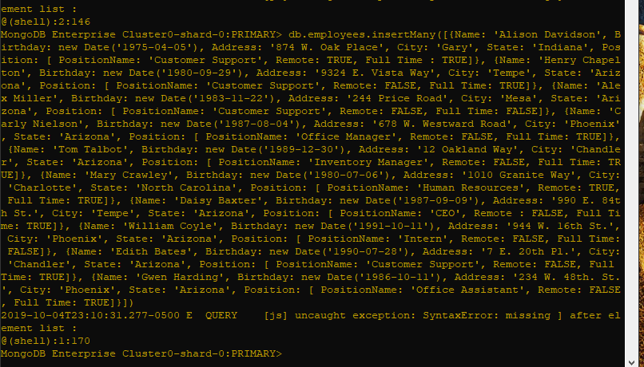

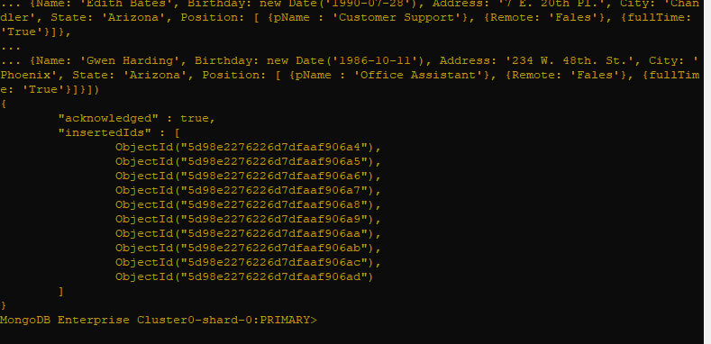
Notes to self: {} for the sub fields.n for data
new Date() for dates…

db.employees.insertMany([{Name: 'Alison Davidson', Birthday: new Date('1975-04-05'), Address: '874 W. Oak Place', City: 'Gary', State: 'Indiana', Position: { pName: 'Customer Support', Remote: 'True', fullTime : 'True'}}, {Name: 'Henry Chapelton', Birthday: new Date('1980-09-29'), Address: '9324 E. Vista Way', City: 'Tempe', State: 'Arizona', Position: { pName: 'Customer Support', Remote: 'Fales', fullTime: 'True'}}, {Name: 'Alex Miller', Birthday: new Date('1983-11-22'), Address: '244 Price Road', City: 'Mesa', State: 'Arizona', Position: { pName: 'Customer Support', Remote: 'Fales', fullTime: 'Fales'}}, {Name: 'Carly Nielson', Birthday: new Date('1987-08-04'), Address: '678 W. Westward Road', City: 'Phoenix', State: 'Arizona', Position: { pName: 'Office Manager', Remote: 'Fales', fullTime: 'True'}}, {Name: 'Tom Talbot', Birthday: new Date('1989-12-30'), Address: '12 Oakland Way', City: 'Chandler', State: 'Arizona', Position: { pName: 'Inventory Manager', Remote: 'Fales', fullTime: 'True'}}, {Name: 'Mary Crawley', Birthday: new Date('1980-07-06'), Address: '1010 Granite Way', City: 'Charlotte', State: 'North Carolina', Position: { pName: 'Human Resources', Remote: 'True', fullTime: 'True'}}, {Name: 'Daisy Baxter', Birthday: new Date('1987-09-09'), Address: '990 E. 84th St.', City: 'Tempe', State: 'Arizona', Position: { pName: 'CEO', Remote : 'Fales', fullTime: 'True'}}, {Name: 'William Coyle', Birthday: new Date('1991-10-11'), Address: '944 W. 16th St.', City: 'Phoenix', State: 'Arizona', Position: { pName: 'Intern', Remote: 'Fales', fullTime: 'Fales'}}, {Name: 'Edith Bates', Birthday: new Date('1990-07-28'), Address: '7 E. 20th Pl.', City: 'Chandler', State: 'Arizona', Position: { pName: 'Customer Support', Remote: 'Fales', fullTime: 'True'}}, {Name: 'Gwen Harding', Birthday: new Date('1986-10-11'), Address: '234 W. 48th. St.', City: 'Phoenix', State: 'Arizona', Position: { pName: 'Office Assistant', Remote: 'Fales', fullTime: 'True'}}])

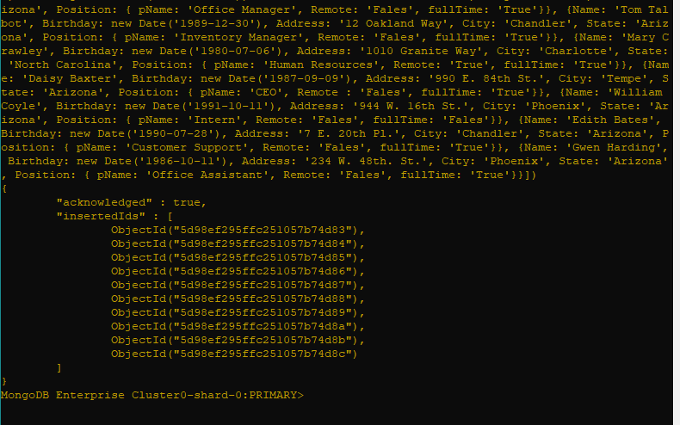

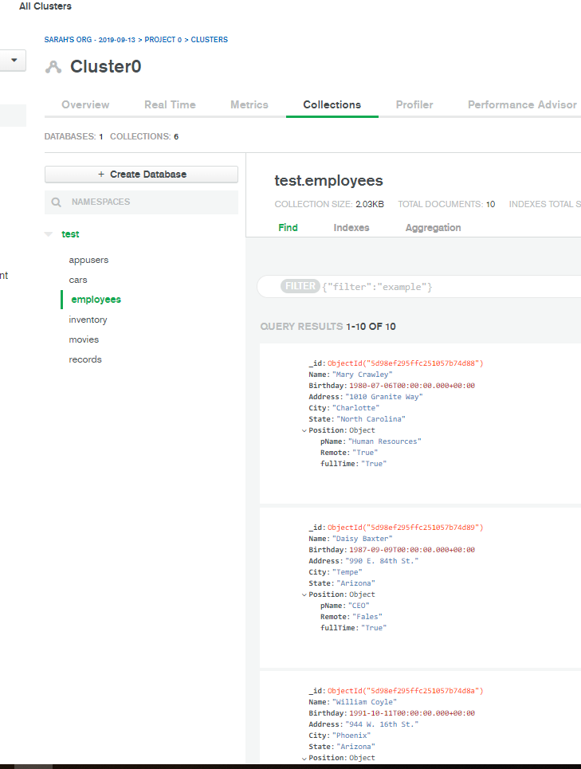
Wahaha :) Perfection!!! :) YAAAAAY!!!!
Moving forward ...bit by bit apparently...
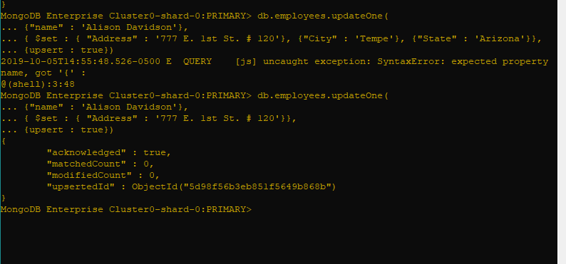
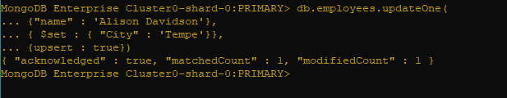
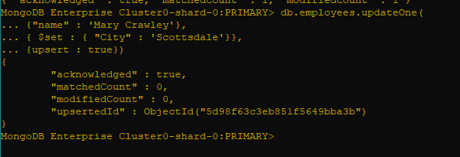

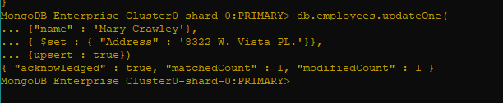

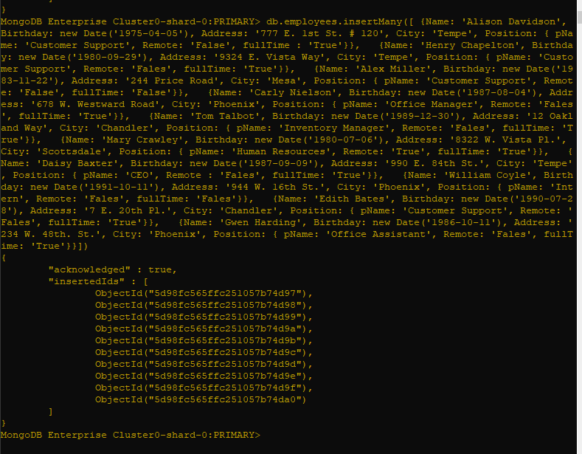

Okay, why did the updating delete everything else?
I went in and corrected the data then inserted it again… :( I’m not sure exactly what happened...but I will keep an eye on the next part.

Part 2
{SongID : , Title : '', Details: {Artist : '', Album: '', ReleaseYr : }},

db.songs.insertMany([ {SongID : 1, Title : 'Girls Just Want To Have Fun', Details: {Artist : 'Cyndi Lauper', Album: 'Shes So Unusual', ReleaseYr : 1983}}, {SongID : 2, Title : 'Hips Dont Lie', Details: {Artist : 'Shakira feat. Wyclef Jean', Album: 'Oral Fixation Vol. 2', ReleaseYr : 2006}}, {SongID : 3, Title : 'Poker Face', Details: {Artist : 'Lady Gaga', Album: 'The Fame', ReleaseYr : 2008}}, {SongID : 4, Title : 'Wannnabe', Details: {Artist : 'Spice Girls', Album: 'Spice', ReleaseYr : 1996}}, {SongID : 5, Title : 'California Gurls', Details: {Artist : 'Katy Perry feat. Snoop Dogg', Album: 'Teenage Dream', ReleaseYr : 2010}}, {SongID : 6, Title : 'Bye Bye Bye', Details: {Artist : 'NSYNC', Album: 'No Strings Attached', ReleaseYr : 2000}}, {SongID : 7, Title : 'I Will Always Love You', Details: {Artist : 'Whitney Houston', Album: 'I Will Always Love You The Best Of Whitney Houston', ReleaseYr : 2012}}, {SongID : 8, Title : 'Baby One More Time', Details: {Artist : 'Britney Spears', Album: 'Baby One More Time', ReleaseYr : 1999}}, {SongID : 9, Title : 'Vogue', Details: {Artist : 'Madonna', Album: 'Im Breathless', ReleaseYr : 1990}}, {SongID : 10, Title : 'Rolling in the Deep', Details: {Artist : 'Adele', Album: 'Im Breathless', ReleaseYr : 1990}}, {SongID : 11, Title : '1234', Details: {Artist : 'Feist', Album: 'The Reminder', ReleaseYr : 2007}}, {SongID : 12, Title : 'Elastic Heart', Details: {Artist : 'Sia', Album: 'The Hunger Games Catching Fire Soundtrack', ReleaseYr : 2015}}, {SongID : 13, Title : 'Oops! I Did It Again', Details: {Artist : 'Britney Spears', Album: 'Oops I Did It Again', ReleaseYr : 2000}}, {SongID : 14, Title : 'Bad Romance', Details: {Artist : 'Lady Gaga', Album: 'The Fame Monster', ReleaseYr : 2009}}, {SongID : 15, Title : 'Lose Control', Details: {Artist : 'Missy Elliot', Album: 'The Cookbook', ReleaseYr : 2005}}, {SongID : 16, Title : 'U Cant Touch This', Details: {Artist : 'MC Hammer', Album: 'Please Hammer, Dont Hurt Em', ReleaseYr : 1990}}, {SongID : 17, Title : 'Thriller', Details: {Artist : 'Michael Jackson', Album: 'Thriller', ReleaseYr : 1982}}, {SongID : 18, Title : 'Single Ladies', Details: {Artist : 'Beyonce', Album: 'I am Sasha Fierce', ReleaseYr : 2008}}, {SongID : 19, Title : 'Rhythm Nation', Details: {Artist : 'Janet Jackson', Album: 'Janet Jacksons Rhythm Nation 1814', ReleaseYr : 1989}}])

At least I had new issues :) I did end up getting it though…

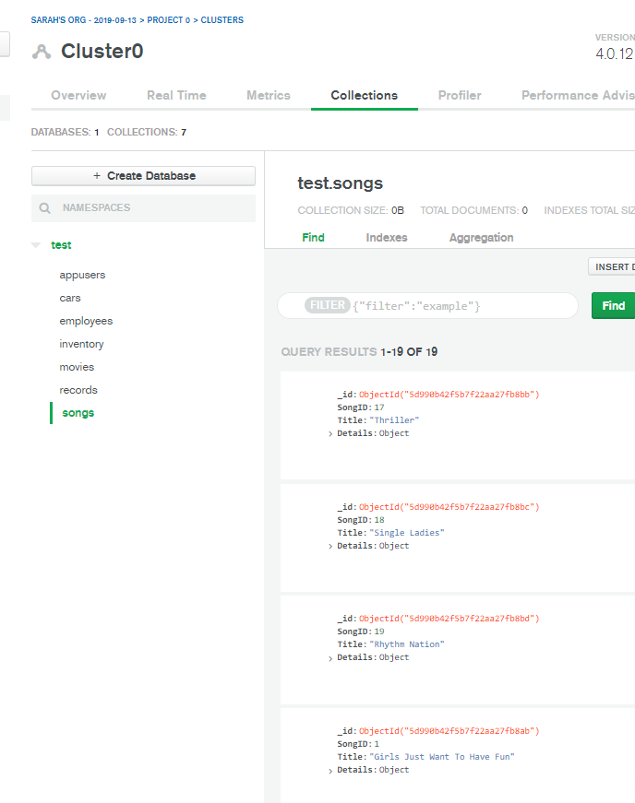

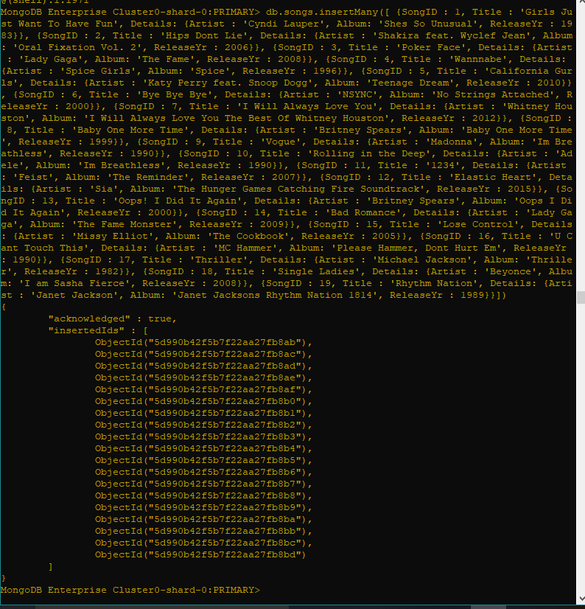

Is it just me...it's easier to delete and redo the data to change it? <maybe I’m a bit of controlling?>
db.songs.insertMany([ {SongID : 1, songTitle : 'Girls Just Want To Have Fun', Artist : 'Cyndi Lauper', Details: { Album: 'Shes So Unusual', ReleaseYr : 1983}},
{SongID : 2, songTitle : 'Hips Dont Lie', Artist : 'Shakira feat. Wyclef Jean', Details: { Album: 'Oral Fixation Vol. 2', ReleaseYr : 2006}},
{SongID : 3, songTitle : 'Poker Face', Artist : 'Lady Gaga', Details: {Album: 'The Fame', ReleaseYr : 2008}},
{SongID : 4, songTitle : 'Wannnabe', Artist : 'Spice Girls', Details: {Album: 'Spice', ReleaseYr : 1996}},
{SongID : 5, songTitle : 'California Gurls', Artist : 'Katy Perry feat. Snoop Dogg', Details: {Album: 'Teenage Dream', ReleaseYr : 2010}},
{SongID : 6, songTitle : 'Bye Bye Bye', Artist : 'NSYNC', Details: { Album: 'No Strings Attached', ReleaseYr : 2000}},
{SongID : 7, songTitle : 'I Will Always Love You', Artist : 'Whitney Houston', Details: {Album: 'I Will Always Love You The Best Of Whitney Houston', ReleaseYr : 2012}},
{SongID : 8, songTitle : 'Baby One More Time', Artist : 'Britney Spears', Details: {Album: 'Baby One More Time', ReleaseYr : 1999}},
{SongID : 9, songTitle : 'Vogue', Artist : 'Madonna', Details: {Album: 'Im Breathless', ReleaseYr : 1990}},
{SongID : 10, songTitle : 'Rolling in the Deep', Artist : 'Adele', Details: {Album: 'Im Breathless', ReleaseYr : 1990}},
{SongID : 11, songTitle : '1234', Artist : 'Feist', Details: {Album: 'The Reminder', ReleaseYr : 2007}},
{SongID : 12, songTitle : 'Elastic Heart', Artist : 'Sia', Details: {Album: 'The Hunger Games Catching Fire Soundtrack', ReleaseYr : 2015}},
{SongID : 13, songTitle : 'Oops! I Did It Again', Artist : 'Britney Spears', Details: {Album: 'Oops I Did It Again', ReleaseYr : 2000}},
{SongID : 14, songTitle : 'Bad Romance', Artist : 'Lady Gaga', Details: {Album: 'The Fame Monster', ReleaseYr : 2009}},
{SongID : 15, songTitle : 'Lose Control', Artist : 'Missy Elliot', Details: {Album: 'The Cookbook', ReleaseYr : 2005}}, {SongID : 16, songTitle : 'U Cant Touch This', Artist : 'MC Hammer', Details: {Album: 'Please Hammer, Dont Hurt Em', ReleaseYr : 1990}},
{SongID : 17, songTitle : 'Thriller', Artist : 'Michael Jackson', Details: {Album: 'Thriller', ReleaseYr : 1982}},
{SongID : 18, songTitle : 'Single Ladies', Artist : 'Beyonce', Details: {Album: 'I am Sasha Fierce', ReleaseYr : 2008}},
{SongID : 19, songTitle : 'Rhythm Nation', Artist : 'Janet Jackson', Details: {Album: 'Janet Jacksons Rhythm Nation 1814', ReleaseYr : 1989}}])

